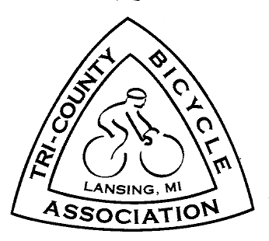

TRI – COUNTY BICYCLE ASSOCIATION
P.O. Box 22146 Lansing, MI 48909-2146 www.biketcba.org

TCBA Policy on the Proposed Bus Rapid Transit
Along the Michigan Avenue/Grand River Avenue Corridor

The Tri-County Bicycle Association (TCBA) supports the Complete Street policies of Meridian Township and the Cities of Lansing & East Lansing.
Thus, any infrastructure for Bus Rapid Transit (BRT) along Michigan and Grand River Avenues should conform to these policies.
We request the Capital Area Transportation Authority work with these governments to insure that there will be safe and convenient bicycling on an eventual BRT route.

Passed by the TCBA Board, May 2, 2016. Chainwheel Chatter Vol. 44, Issue 6 (June 2016), page 3.

